Multiple choice section

|  |  |  |  |  |  |  |  |  |  |  |
| --- | --- | --- | --- | --- | --- | --- | --- | --- | --- | --- |
| Question | 1 | 2 | 3 | 4 | 5 | 6 | 7 | 8 | 9 | 10 |
| Answer | A | D | D | C | A | B | D | D | C | B |

Question 1 [8.2]

A

20° is acute, 160° is obtuse. They add to 180°.

Question 2 [8.3]

D

Complementary angles add to 90°.

90 – 52 = 38°

Question 3 [8.6]

D

Question 4 [8.3]

C

Angles in a revolution add to 360°.

360 – (26 + 178) = 156°

Question 5 [8.6]

A

Scalene because all side lengths are different and appears obtuse-angled.

Question 6 [8.4]

B

Question 7 [8.5]

D

Undecagon is an 11-sided shape.

Question 8 [8.7]

D

A rectangle and parallelogram

Question 9 [8.2]

C

a straight angle

Question 10 [8.4]

B

Co-interior angles add to 180°.

Multiple-choice total marks: 10

Short answer section

Question 11 3 marks [8.1, 8.2]

(a) 180° + 30° = 210°

(b) 360° − 47° = 313°

(c) reflex ∠ADF

Question 12 2 marks [8.1]

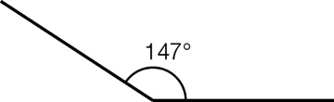

Question 13 5 marks [8.2]

(a) acute angles: ∠AOB, ∠BOD, ∠COE, ∠DOE, ∠COD

(b) obtuse angle: ∠AOD, ∠BOE, ∠AOC

(c) straight angle: ∠AOE

Question 14 5 marks [8.3]

(a) x + 39 + 123 = 180  
(supplementary angles add to 180°)  
x = 18°

(b) 2x + 3x + 5x + 70 = 360  
(angles in a revolution add to 360°)  
10x + 70 = 360  
10x = 290  
x = 29

Question 15 2 marks [8.4]

x + 57 = 180

x = 123°

(co-interior angles on parallel lines)

(vertically opposite angles equal)

Question 16 4 marks [8.5]

Triangle, square, hexagons and dodecagons

Question 17 4 marks [8.6]

(a) x = 118 + 38  
(exterior angle of a triangle)  
x = 156°

(b) 79 – 39 = x  
(exterior angle of a triangle)  
x = 40°

Question 18 3 marks [8.7]

x + x + 115 + 31 = 360

2x + 146 = 360

(angle sum of a quadrilateral)

2x = 214

(opposite angles in a kite are equal)

x = 107°

Question 19 3 marks [8.7]

Let x represent the opposite angle to the 55°.

x = 55°

(opposite angles in a parallelogram are equal)

Let y represent the unknown angles.

y + y + 55 + 55 = 360

(angle sum of a quadrilateral)

2y + 110 = 360

2y = 250

y = 125°

(opposite angles in a parallelogram are equal)

Question 20 4 marks [8.8]

Draw a line segment AB.

Then draw a third point C (as you would for creating an equilateral triangle).

Bisect the angle ∠A.

Label the 30° angle.

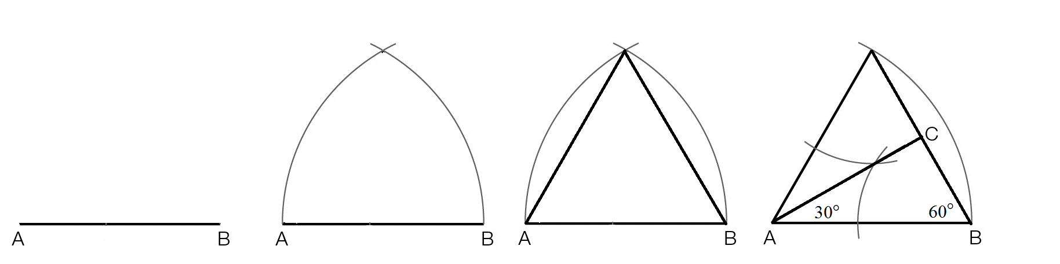

Question 21 4 marks [8.8]

135 = 90 + 45

Draw a line segment AB, bisect the line and lightly draw the perpendicular. Bisect one of the right angles formed. Then draw a line. Label the angle appropriately.

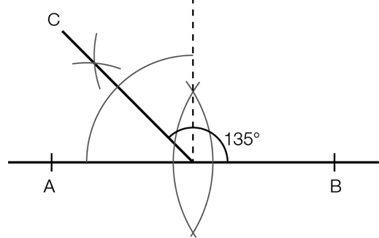

Question 22 4 marks [8.6]

∠AGC = 30° and ∠EID = 51° (given)

∠HGI = 30°

(vertically opposite angles are equal)

∠GIH = 51°

(vertically opposite angles are equal)

∠HGI + ∠GIH + ∠GHI = 180

(angle sum of a triangle)

30 + 51 + ∠GHI = 180

∠GHI = 99°

x = 99°

(vertically opposite angles are equal)

Short answer total: 43

Extended answer section

Question 23 6 marks [8.6]

180° in any triangle

x + y + 80° = 180°

x + y = 100°

(180° in a straight angle)

2x + a = 180°

2y + b = 180°

Add two equations immediately above

2(x + y) + a + b = 360°

200° + a + b = 360°

a + b = 160°

d is exterior angle equal to a + b

d = 160°

Question 24 3 marks [8.6]

x + 2y = 180°

x = 3y

substitute x for 3y

3y + 2y = 180°

5y = 180°

y = 36°

x = 108°

Question 25 5 marks [8.3]

∠EGB = 142 and ∠DGF = 119 (given)

∠FGE = straight angle = 180°

(supplementary angles add to 180°)

∠FGB = 180 – ∠EGB

∠FGB = 180 – 142

∠FGB = 38°

(supplementary angles add to 180°)

∠BGF = ∠DGF – 38

∠DGB = 81°

(vertically opposite angles)

∠AGC = 81°

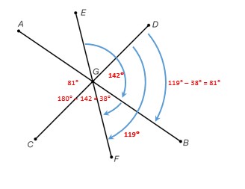

Question 26 5 marks [8.5]

(a)   
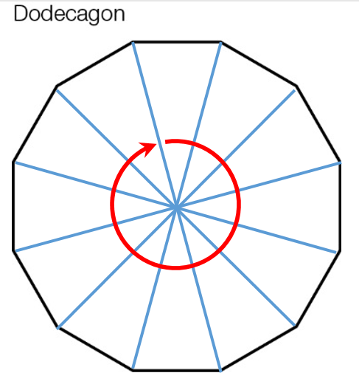

(b) (n – 2) × 180  
n = 12  
(12 – 2) × 180  
10 × 180 = 1800  
Angle sum of a dodecagon = 1800°

(c) Alternative method  
Construct 12 isosceles triangles inside dodecahedron  
360° ÷ 12 = 30° smallest angle inside each isosceles triangle  
180 – 30 = 150°

(d) 1800 ÷ 12 = 150  
The size of one angle is 150°.

Extended answer total: 19

TOTAL test marks: 82